**Joseph Walker**

**06/19/2017**

**Data Science & Analytics: Case Study**

**Excel Tools: Krrazy Apps**

You are the data scientist for Krrazy Apps!, a developer of multi-player games, delivered as apps for the Apple iPhone and Samsung Galaxy smart phones. You produce four different games, listed below. Each app generates revenue and requires resources to develop and deliver to market.

* Maniac! Smart phone game app featuring a Tazmanian devil character
* Kitten! Smart phone game app featuring a cute cuddly kitten
* Vagabond! Smart phone game app featuring travel to exotic locations
* Tank! Smart phone game app featuring desert-based tank battles

Krrazy Apps! is looking to you to decide how many of each app to produce and sell. To determine the correct mix of apps to produce and sell, you go to the Finance department to find out the per-unit revenue each app generates, as well as the license fees associated with each per-unit sale. You also learn from Finance that you cannot spend more than $20,000 in license fees per month. The table below summarizes revenue and license fee data.

|  |  |  |  |  |
| --- | --- | --- | --- | --- |
| **Revenue/Cost** | **Maniac! (M)** | **Kitten! (K)** | **Vagabond! (V)** | **Tank! (T)** |
| Revenue | $50 | $40 | $30 | $20 |
| License Fees | $20 | $10 | $10 | $20 |

In order to deliver each app, labor is required from the product manager, developer, and test manager shared across the four apps. None of them wants to work weekends, so they are all constrained by a certain number of hours worked per month. The table below summarizes the labor required from each resource on a per-unit basis, as well as the total number of hours available each month from each resource.

|  |  |  |  |  |  |
| --- | --- | --- | --- | --- | --- |
| **Resource** | **Maniac (M)** | **Kitten! (K)** | **Vagabond (V)** | **Tank! (T)** | **Total Hr/Mo.** |
| Product Mgr. | 3 | 2 | 2 | 3 | 160 |
| Developer | 4 | 2 | 3 | 2 | 160 |
| Test Manager | 1 | 3 | 4 | 1 | 160 |

1. *Develop the objective equation to maximize revenue. Remember, you are selecting a product mix (selecting how many of each app to sell) to generate as much money as possible.*

Z = 50*M + 40*K + 30*V + 20*T

1. *Develop the relevant constraints equations. Add constraints to ensure that the number of each app sold is an integer value. Krrazy Apps! does not have a way to sell fractions of an app.*

|  |  |
| --- | --- |
| License Fee | B = 20*M + 10*K + 10*V + 20*T <= 20,000 |
| Product Mgr. | P = 3*M + 2*K + 2*V +3*T <= 160 |
| Developer | D = 4*M + 2*K + 3*V + 2*T <= 160 |
| Test Manager | T = 1*M + 3*K + 4*V + 1*T <= 160 |

1. *Calculate the optimum value for the number of Maniac!, Kitten!, Vagabond, and Tank! apps to sell, given the constraints. Use Microsoft Excel Solver.*

Table 1: Optimum Value Results

|  |  |
| --- | --- |
| Maniac! | 16 |
| Kitten! | 48 |
| Vagabond | 0 |
| Tank! | 0 |
| Total Revenue | 2720 |
| Budget Usage | 800 |

Figure 1: Excel Solver Template

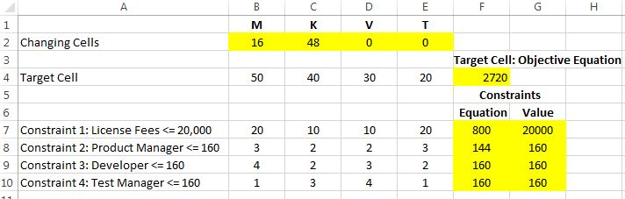

Figure 2: Excel Solver Report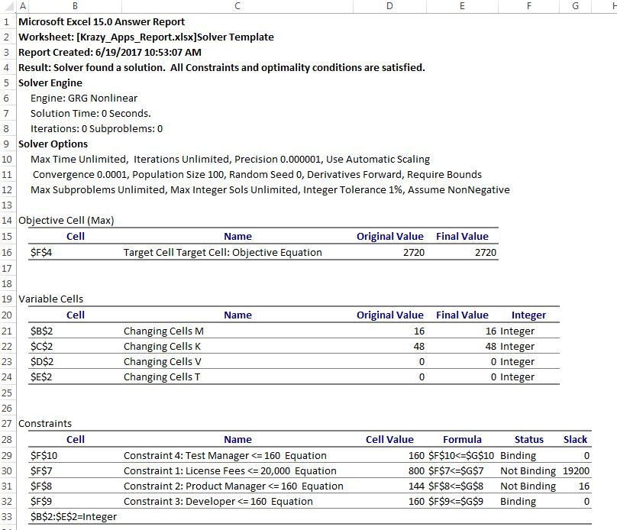

*Commentary: Discuss your observations on the case. Are the labor resources being used wisely? Include comparisons to product mix decisions software companies typically make.*

In order to achieve a maximum monthly revenue of $2,720, we should focus on two products, Maniac! and Kitten! by producing 16 units of the former and 48 units of the later. With respect to licensing fees, we only need to spend $800 of the $20,000 the finance department has constrained us to.

It appears that some of our human resource allocation is being underutilized. To maximize product output, product managers are expected to work only 144 hours even though their available to work up to 160 hours per month.

Similar to Krrazy Apps, software companies such as Zynga, Electronic Arts, and Activision Blizzard have increased their focus on mobile gaming. Over the past decade, the market has grown exponentially thanks to advancements in mobile device technology.

According to 2015 Google & Apple app store data from Statista, the majority of revenue related to mobile gaming apps is generated through the purchase of the app itself, accounting for nearly 60% of total revenue.[1] According to their website, Zynga currently has 32 games on the market including their most popular game, Farmville which has been played by over 400 million people alone.[2] While a diverse product portfolio is surely to increase business, not all customers are willing to pay up front for a game/app. Making a purchase can be risky for a customer and gaming companies are responding to this by making their games free or charging a nominal fee. Two widely popular games in recent years, Pokemon Go and Farmville are perfect examples of this. According to app store data from Statista, the average price for a gaming app in March 2017 was 48 cents.[3] Currently, the top grossing gaming app in the apple app store is Clash of Clans™ which can be downloaded for free.[4] So how are these companies making any money then?

Rather than charging up front, companies are switching their focus to in-app purchases. Add-ons such as level-ups, extra credits to play, new levels or scenarios, or items that consumers can acquire immediately, rather than having to spend longer periods of time playing the game to achieve them, are frequently made available to the player at a price. By connecting their credit card information to the game, it is often as easy as clicking a button on your screen to make these purchases. According to data from Statista, in-app purchase gross revenue grew from 9% in 2011 to 31% in 2015 and is estimated to increase to 48.2% this year.[5]

Another revenue channel is advertising. Companies will advertise products or other games in their portfolio, a strategy known as cross-promotion, during game play. These ads usually appear full screen for a brief time period in between play, known as interstitial ads, or will remain constant as banners on some part of the screen. In Q1 of 2017, Zynga reported $40.8 million in advertising revenue, 21% of overall revenue.[6] Advertising revenue could go up for the mobile gaming industry as a whole as marketers figure out what type of advertising appeals most to gamers. According to reach from Unity Technologies, rewards based video ads were preferred by 46% of gamer and that 78% of mobile gamers were open to engaging with video ads for in-game rewards.[7]

In summary, gaming companies are focused on mobile games now more than ever. And despite up front app purchases being the largest revenue source, a significant trend toward offering apps at little to no cost is on the rise. In app-purchases continues to be the focus for revenue for the market as a whole with significant growth outlook. As the mobile gaming community continues to rise and gamers play more for longer, marketers are honing in how to maximize advertising revenue.

1. Medium.com <https://medium.com/@sm_app_intel/mobile-app-industry-revenue-statistics-wheres-the-money-come-from-82581a45186d>
2. Zynga.com <https://www.zynga.com/about>
3. Statista.com <https://www.statista.com/statistics/267346/average-apple-app-store-price-app/>
4. Appannie.com <https://www.appannie.com/en/apps/ios/top/>
5. Businessofapps.com <http://www.businessofapps.com/app-revenue-statistics/>
6. Zynga Q1 2017 Financial Results <http://files.shareholder.com/downloads/AMDA-KX1KB/4668843153x0x941196/E7EF1922-562C-413F-90FD-B615280B1215/Q1_2017_Earnings_Slides.pdf>
7. Fiercewireless.com <http://www.fiercewireless.com/developer/mobile-game-devs-see-higher-revenue-from-game-ads-says-unity-technologies>